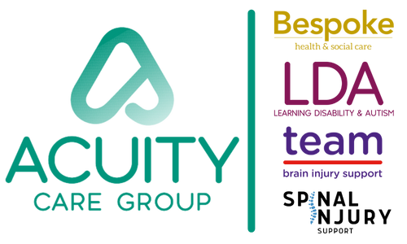

**Job Description & Person Specification**

|  |  |
| --- | --- |
| Details |  |
| Department | Quality |
| Job Title | Quality Improvement Officer |
| Reports to | Head of Quality & Improvement |
| Supervises | **N/A** |

|  |
| --- |
| **Role Purpose** |

The primary purpose of the Quality Improvement Officer is to play a key role in providing a consistent and efficient Quality Assurance and Compliance Framework.

Reporting directly to the Head of Quality & Improvement, working with the Quality Improvement Manager and identified team members across Acuity Care Group

|  |
| --- |
| **Primary Responsibilities** |
| * To support the implementation of best practice quality strategy, policies, processes and procedures to aid and improve business performance across the group. * Take action to mitigate risks and develop opportunities creating a proactive culture so that people we support receive the highest standard of quality possible. * Supporting a culture of curiosity and continuous learning; contributing to any necessary culture change and improvement in business performance to deliver strategic quality goals. * Report on Quality activities on a regular basis (for Governance and ELT meetings), ensuring accurate and timely reporting of the relevant Quality Key Performance Indicators. * Assist in continuous improvement activities throughout the business ensuring that problems are prevented and that people we support requirements are met with any problems resolved effectively and economically. * Contribute to the development of effective processes for quality management that include quality performance, risk management and learning outcomes. * Ensure the completion of allocated audits * Work with colleagues to support the continual review of audits to meet business priorities, ensuing regulatory requirements are met and avoiding duplication within Clinical Audit. * Ensure that corrective actions are delivered, and non-compliance issues are resolved on time. * Work closely with the Head of Quality & Improvement for the Group to develop improvement and communication of quality and governance protocols within all systems and processes across the business. * Provide guidance to colleagues and other departments creating buy-in on the importance of quality and improvement. * Responsible for identified CQC quality activities within the business to ensure we are inspection ready with the aim of achieving good or outstanding rating. * Ensuring you keep updated with all regulatory and relevant changes and cascade information through the business appropriately whilst implementing any changes needed thereafter. * Following all requirements with regard to CQC ensuring transparency in reporting, investigating and identifying lessons learnt and thereafter ensuring appropriately cascaded through the group to ensure quality is continually evolving and improvements are at forefront of everything. * Attending relevant Governance, Safeguarding and Managers’ meetings and cascading any information to the relevant parts of the business * Tracking of Safeguarding, complaints, incidents to ensure they are brought to a successful conclusion within a timely manner * Supporting care teams with Safeguarding, incidents and complaints. * Working with Registered Managers (RMs) to raise any reportable events with the relevant bodies i.e. CQC, RIDDOR * Working closely with the Operations Managers/RMs and Complex Nurse Specialists to drive quality within the business. * Carry out People we Support Satisfaction Surveys to measure and monitor quality of service. * Having identified responsibilities for the implementation of PSIRF across the business. |
| **Other Tasks** |
| * The role will be home based with planned visits for face-to-face audits and to the office in Nottingham for meetings. * Build and maintain effective working relationships with key members across the business. * To deputise for the Quality Improvement Manger or Head of Quality & Improvement in their absence |
| **Key Skills & Experience** |
| * Excellent interpersonal and communication skills. * Experience in a Quality role e.g. Registered Manager or Quality Assurance in a healthcare/social care setting * Experience of working within a creative and innovative environment and using a range of reporting tools and evidence to inform and improve practice * Experience of CQC regulatory compliance framework and maintaining high standards of quality and safety. * Monitoring and reporting quality, safety and operational KPIs for assurance and improvement. * Excellent IT skills. * Highly numerate and excellent analytical skills. * NVQ Level 4 or equivalent * Experience of auditing. * Experience of policy and procedure review, writing and development * Full driving license and car available at all times. * Resilient and able to work at a pace and manage competing priorities. * Presentation skills – desirable. * Preferred location – South, but not essential   **Values and Attitudes**   * Passion for making a positive difference in the lives of others. * Commitment to Acuity Care Group’s values. |